OREGON INSTITUTE OF TECHNOLOGY
Computer Systems Engineering Technology Department
CST 315 – Embedded Sensor Interfacing I/O
Lab 5 – Battery Discharge Curve
Name: ___Chris Thomas_______________________
PURPOSE:
The purpose of this lab is to study the characteristics of a 9V Alkaline Battery’s Discharge Curve, and how to determine the Ah rating of a battery, and the Wh rating of a battery. The use of a RPi Pico as a datalogger is also demonstrated,
EQUIPMENT AND SUPPLIES:
- RPi Pico with USB cable
- DMM with probes
- 1 – diode 1N4007
- 1 – 2.2K resistor
- 1 – 1.0K resistor
- 1 –100 Ohm, Power resistor
- 2 – 7805 5 V. Voltage Regulators
- 2 – 9V Alkaline Batteries
- 1- push button switch
- wire
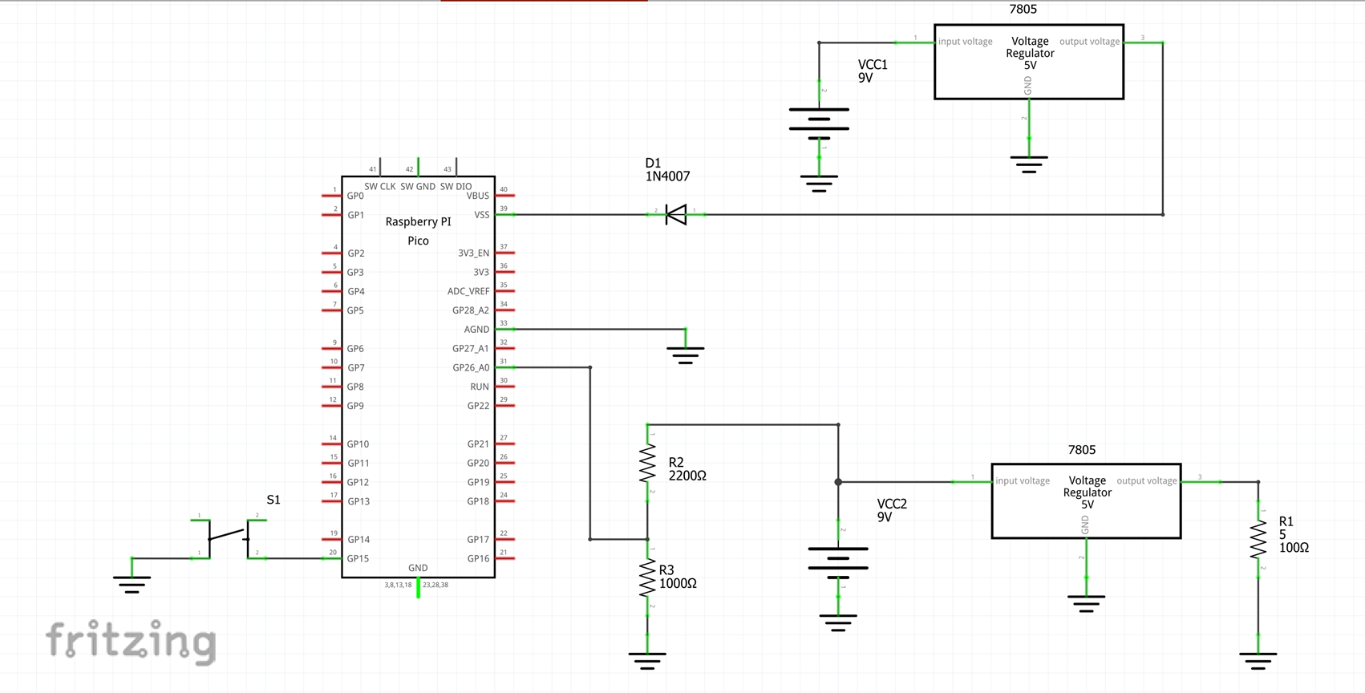

Schematic Diagram
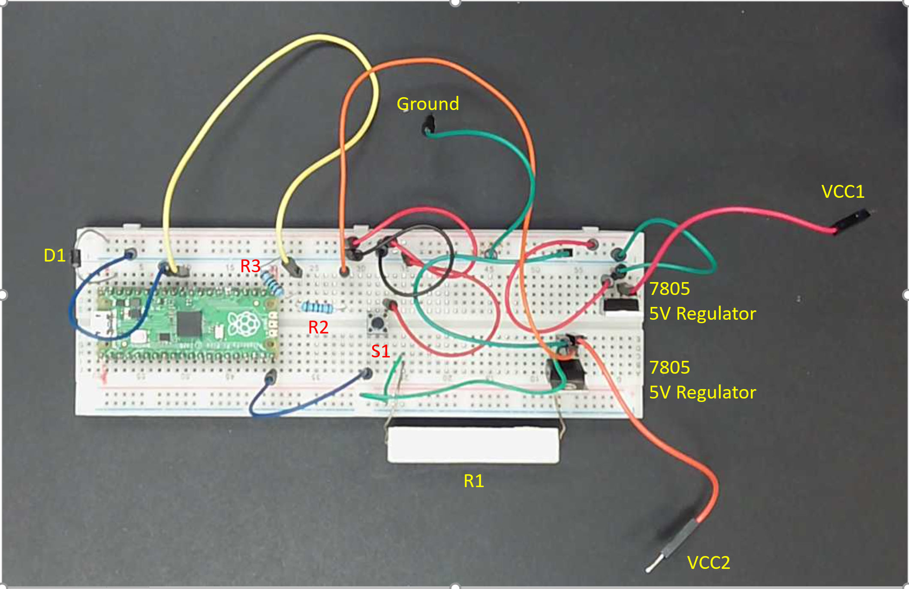
Pictorial Diagram
Build and Test Battery Discharge Test System

- Measure and record the resistances of R2 and R3. R2 = ____2.2k_______; R3 = ____997_______
- Build circuit shown in schematic and pictorial diagram above. Do not attach batteries at this time.
- Check circuit wiring.
- Download to your computer the program TEST_battery_voltage_logger.py from Canvas (or Kansas) Supplemental Materials. Open the downloaded code with Thonny.
- Save the program to the RPi Pico.
- Attach the 9V batteries to the Pico.
- Start the code by clicking the run icon in the Thonny IDE.
- You should see a column of 1’s scrolling up from the bottom of the screen. Press and hold the push button switch S1 until voltage values appear at the bottom of the screen. Release S1. The onboard LED should start to blink and continue to blink for as long as data are being collected.
- The system will collect 100 voltage samples and then stop sample collection.
- Disconnect the two batteries and the USB cable to the Pico. By doing this you are simulating the system running disconnected from the computer until the batteries die. You should also turn off Thonny since you will probably not have Thonny running during the long duration battery discharge test.
- Restart Thonny.
- Reconnect the USB cable between your computer and the Pico.
- Click on the Stop icon in the Thonny IDE. The Pico should be reconnected to the IDE. A list of files stored on the Pico should appear on the left side of the IDE screen. Scroll down the list until you see the file named “volts.txt”.
- Double click on volts.txt and the voltage readings collected by the Pico should appear in the IDE’s editor.
- Copy the voltage readings and paste them into a spreadsheet. After data has been safely copied to your spreadsheet erase the volts.txt file from Thonny.
- This completes the test of your setup.

9V Alkaline Battery Discharge Test

- Download the code named “battery_voltage_logger.py from Canvas and open the code with Thonny.
- Repeat steps 4, 5, 6, and 7 above. After you start data collection you can disconnect the USB cable between the Pico and your computer.
- The code will collect 600 samples at a rate of one sample per minute. It will collect battery voltage data for ten hours before stopping.
- Start Thonny on your computer.
- Repeat steps 12. 13, 14 and 15 above.
- From the battery voltage data collected you will produce two charts. The first chart will plot battery terminal voltage v time, and the second will plot battery terminal voltage v Ah. Be sure to title each chart and label the axes. The short table below gives my suggestions for spreadsheet column headings. Remember that you will be recording the input voltage to the Pico’s ADC not the terminal voltage of the battery. A voltage divider (R2 and R3) is used to reduce the terminal voltage of the battery to a voltage level (<3.3V) that is safe for the Pico ADC input pin. Please remember to take that into account when calculating the battery terminal voltage. Also, recall that the Ah rating of the battery will be the number of Ah delivered by the battery to the resistor at the point where the abrupt change of terminal voltage occurs.

Sample # | Time (Hours) | ADC Voltage Input | Battery Terminal Voltage | A-Hr
0 | 0 | 2.825356 | 9.16828022 | 0
1 | 0.01666667 | 2.811659 | 9.123833455 | 0.000833
2 | 0.03333333 | 2.796351 | 9.074158995 | 0.001667

- Deliverables:
- Chart of Battery Terminal Voltage v Time (See example of this file on next page.)
- Chart of Battery Terminal Voltage v Ah delivered to the Resistor
- Ah rating of the battery.
- Wh rating of the battery.

